Experiment 2
Noise Removal Comparison
Image Feature Extraction, Detection & Matching Laboratory
C03-AT1
Name: PRAKASH.K
Reg. No: 192521081
Course: Computer Vision
Course Code: ITA0518
Faculty Name: Dr. T. Usha

Objective
To perform a comparative study of different noise-removal (denoising) techniques applied to images corrupted with several common noise models, and to analyze how effectively each technique removes noise while preserving genuine image detail.

1. Understanding of Concepts
Image noise is unwanted random variation in pixel intensity introduced during acquisition (sensor thermal noise, low-light shot noise), transmission, or quantization. Three common models were studied here: additive Gaussian noise (continuous random fluctuation, typical of sensor/thermal noise), salt-and-pepper impulse noise (isolated pixels randomly forced to pure black or pure white, typical of transmission bit errors or dead sensor pixels), and multiplicative speckle noise (signal-dependent noise common in radar, ultrasound and coherent imaging).
Spatial filters remove noise by combining each pixel with its neighbourhood. Linear filters (mean/box filter, Gaussian filter) replace a pixel with a weighted average of its neighbours; they suppress Gaussian noise effectively but also blur edges because they average across discontinuities. Non-linear filters such as the median filter replace a pixel with the median of its neighbourhood, which is highly effective against impulse (salt-and-pepper) noise because a single extreme outlier cannot dominate a rank statistic. The bilateral filter extends Gaussian smoothing with an additional range/intensity weighting term so that only neighbours with similar intensity contribute, which suppresses noise while better preserving sharp edges. Non-local means (NLM) generalizes this idea further by searching the whole image for patches similar to the one being denoised and averaging across all of them, which typically gives the best detail-preservation/noise-suppression trade-off for Gaussian noise at the cost of higher computational complexity.
Denoising quality was measured objectively using two standard full-reference metrics: PSNR (Peak Signal-to-Noise Ratio, in dB, measuring pixel-wise fidelity to the clean reference; higher is better) and SSIM (Structural Similarity Index, in the range [0,1], measuring perceptual/structural similarity including edges and texture; higher is better).

2. Experimental Design
- A single synthetic 384x384 grayscale reference image containing flat regions, sharp edges (rectangle, circle, bar, triangle) and a smooth gradient band was used as ground truth so that PSNR/SSIM could be computed exactly against a known-clean reference.
- Three noisy versions were generated independently: additive Gaussian noise (sigma=25), salt-and-pepper noise (5% of pixels corrupted), and multiplicative speckle noise (variance 0.05).
- For each noisy image, five denoising filters were applied under matched, realistic parameter settings: Mean filter (5x5), Gaussian filter (5x5, sigma=1.2), Median filter (5x5), Bilateral filter (d=9, sigmaColor=sigmaSpace=75), and Non-Local Means (h=22, 7x7 template, 21x21 search window).
- Dependent variables: PSNR and SSIM of each filtered output relative to the clean reference image, computed for all 5 filters x 3 noise types (15 filtered results total), plus the un-filtered noisy baseline for each noise type.
- This 3 (noise type) x 6 (no-filter + 5 filters) factorial design isolates which filter is best suited to which noise model, rather than assuming one filter is universally best.

3. Use of Tools
- Python 3 as the implementation language.
- OpenCV (cv2) for all filtering operations: cv2.blur, cv2.GaussianBlur, cv2.medianBlur, cv2.bilateralFilter, and cv2.fastNlMeansDenoising.
- scikit-image (skimage.metrics) for the peak_signal_noise_ratio and structural_similarity quality metrics.
- NumPy for synthetic image and noise generation.
- Matplotlib for the comparison image grids and the PSNR bar charts.
Complete implementation:
"""
Experiment 17: Noise Removal Comparison
========================================
Objective:
Compare several classical noise-removal (denoising) filters and
quantify how well each preserves image detail while removing noise.

Tools:
Python 3, OpenCV (cv2), NumPy, Matplotlib, scikit-image (metrics)

Output:
outputs/01_noisy_inputs.png - clean image + gaussian/salt&pepper/speckle noise
outputs/02_filters_gaussian.png - filter comparison for gaussian noise
outputs/03_filters_sp.png - filter comparison for salt & pepper noise
outputs/04_metrics_bar.png - PSNR / SSIM bar charts
outputs/metrics.csv
"""

import os
import cv2
import numpy as np
import matplotlib
matplotlib.use("Agg")
import matplotlib.pyplot as plt
from skimage.metrics import peak_signal_noise_ratio as psnr
from skimage.metrics import structural_similarity as ssim

OUT = os.path.join(os.path.dirname(__file__), "outputs")
os.makedirs(OUT, exist_ok=True)
np.random.seed(7)

# ---------------------------------------------------------------------------
# 1. Test image + three noise models
# ---------------------------------------------------------------------------
def make_test_image(size=384):
img = np.zeros((size, size), np.uint8)
cv2.rectangle(img, (30, 30), (170, 170), 210, -1)
cv2.circle(img, (280, 100), 70, 130, -1)
cv2.rectangle(img, (50, 220), (330, 250), 170, -1)
pts = np.array([[70, 300], [230, 300], [150, 370]], np.int32)
cv2.fillPoly(img, [pts], 90)
x = np.linspace(0, 1, size)
grad = (60 + 100 * x).astype(np.uint8)
img[:, :] = np.maximum(img, np.tile(grad, (size, 1)) // 4)
return img

def gaussian_noise(img, sigma=25):
n = np.random.normal(0, sigma, img.shape)
return np.clip(img.astype(np.float32) + n, 0, 255).astype(np.uint8)

def salt_pepper_noise(img, amount=0.05):
out = img.copy()
n_pixels = img.size
n_salt = int(amount * n_pixels * 0.5)
n_pepper = int(amount * n_pixels * 0.5)
ys = np.random.randint(0, img.shape[0], n_salt)
xs = np.random.randint(0, img.shape[1], n_salt)
out[ys, xs] = 255
ys = np.random.randint(0, img.shape[0], n_pepper)
xs = np.random.randint(0, img.shape[1], n_pepper)
out[ys, xs] = 0
return out

def speckle_noise(img, var=0.05):
n = np.random.randn(*img.shape) * np.sqrt(var)
out = img.astype(np.float32) + img.astype(np.float32) * n
return np.clip(out, 0, 255).astype(np.uint8)

clean = make_test_image()
noisy_gauss = gaussian_noise(clean)
noisy_sp = salt_pepper_noise(clean)
noisy_speckle = speckle_noise(clean)

fig, ax = plt.subplots(1, 4, figsize=(14, 4))
for a, im, t in zip(ax, [clean, noisy_gauss, noisy_sp, noisy_speckle],
["Clean", "Gaussian noise", "Salt & Pepper", "Speckle noise"]):
a.imshow(im, cmap="gray"); a.set_title(t); a.axis("off")
plt.tight_layout()
plt.savefig(os.path.join(OUT, "01_noisy_inputs.png"), dpi=150)
plt.close()

# ---------------------------------------------------------------------------
# 2. Filters under test
# ---------------------------------------------------------------------------
def apply_filters(img):
return {
"Mean (5x5)": cv2.blur(img, (5, 5)),
"Gaussian (5x5)": cv2.GaussianBlur(img, (5, 5), 1.2),
"Median (5x5)": cv2.medianBlur(img, 5),
"Bilateral": cv2.bilateralFilter(img, 9, 75, 75),
"Non-Local Means": cv2.fastNlMeansDenoising(img, None, h=22, templateWindowSize=7, searchWindowSize=21),
}

def evaluate(clean_img, noisy_img, filtered_dict):
results = []
base_psnr = psnr(clean_img, noisy_img)
base_ssim = ssim(clean_img, noisy_img)
results.append({"filter": "No filtering (noisy)", "psnr": base_psnr, "ssim": base_ssim})
for name, out in filtered_dict.items():
results.append({"filter": name, "psnr": psnr(clean_img, out), "ssim": ssim(clean_img, out)})
return results

def plot_grid(clean_img, noisy_img, filtered_dict, title, fname):
n = len(filtered_dict) + 2
fig, axes = plt.subplots(1, n, figsize=(3 * n, 3.4))
axes[0].imshow(clean_img, cmap="gray"); axes[0].set_title("Clean"); axes[0].axis("off")
axes[1].imshow(noisy_img, cmap="gray"); axes[1].set_title("Noisy"); axes[1].axis("off")
for a, (name, out) in zip(axes[2:], filtered_dict.items()):
a.imshow(out, cmap="gray"); a.set_title(name, fontsize=9); a.axis("off")
fig.suptitle(title)
plt.tight_layout()
plt.savefig(os.path.join(OUT, fname), dpi=150)
plt.close()

filt_gauss = apply_filters(noisy_gauss)
filt_sp = apply_filters(noisy_sp)
filt_speckle = apply_filters(noisy_speckle)

plot_grid(clean, noisy_gauss, filt_gauss, "Filters applied to Gaussian noise", "02_filters_gaussian.png")
plot_grid(clean, noisy_sp, filt_sp, "Filters applied to Salt & Pepper noise", "03_filters_sp.png")

# also save speckle grid for completeness
plot_grid(clean, noisy_speckle, filt_speckle, "Filters applied to Speckle noise", "03b_filters_speckle.png")

# ---------------------------------------------------------------------------
# 3. Metrics table + bar chart
# ---------------------------------------------------------------------------
all_rows = []
for noise_name, noisy_img, filt in [("gaussian", noisy_gauss, filt_gauss),
("salt_pepper", noisy_sp, filt_sp),
("speckle", noisy_speckle, filt_speckle)]:
for r in evaluate(clean, noisy_img, filt):
r["noise_type"] = noise_name
all_rows.append(r)

import csv
with open(os.path.join(OUT, "metrics.csv"), "w", newline="") as f:
writer = csv.DictWriter(f, fieldnames=["noise_type", "filter", "psnr", "ssim"])
writer.writeheader()
for r in all_rows:
writer.writerow({"noise_type": r["noise_type"], "filter": r["filter"],
"psnr": round(r["psnr"], 2), "ssim": round(r["ssim"], 3)})

fig, axes = plt.subplots(1, 3, figsize=(16, 5))
for ax, noise_name in zip(axes, ["gaussian", "salt_pepper", "speckle"]):
subset = [r for r in all_rows if r["noise_type"] == noise_name]
names = [r["filter"] for r in subset]
psnrs = [r["psnr"] for r in subset]
ax.bar(range(len(names)), psnrs, color="teal")
ax.set_xticks(range(len(names)))
ax.set_xticklabels(names, rotation=45, ha="right", fontsize=8)
ax.set_ylabel("PSNR (dB)")
ax.set_title(f"{noise_name} noise")
ax.grid(axis="y", alpha=0.3)
plt.tight_layout()
plt.savefig(os.path.join(OUT, "04_metrics_bar.png"), dpi=150)
plt.close()

print("Done. Results written to", OUT)
for r in all_rows:
print(r)

4. Results
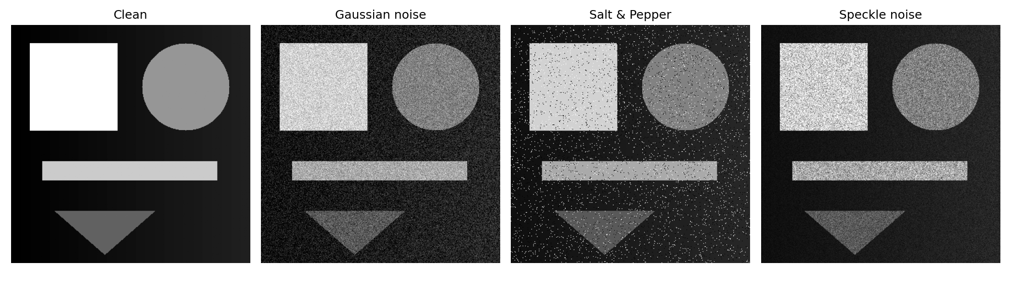
Figure 1. Clean reference image and the three noise models applied to it: Gaussian, salt-and-pepper, and speckle.
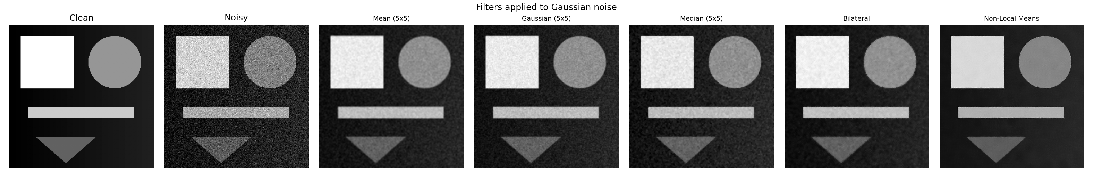
Figure 2. Comparison of all five filters applied to Gaussian-noise-corrupted image.
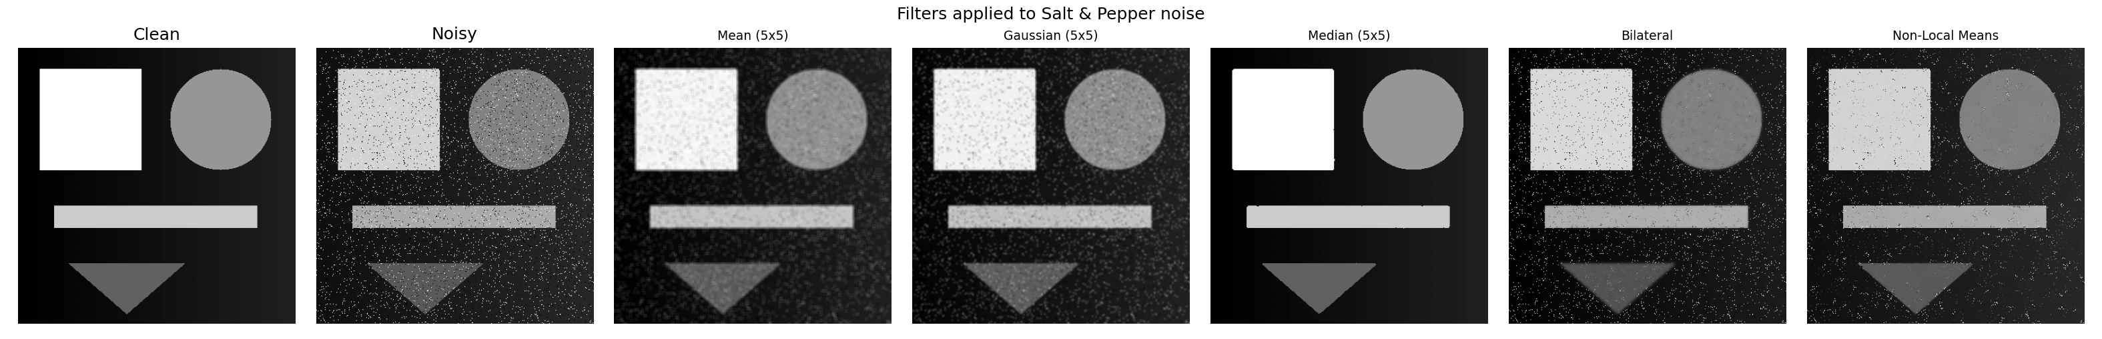
Figure 3. Comparison of all five filters applied to salt-and-pepper-noise-corrupted image.
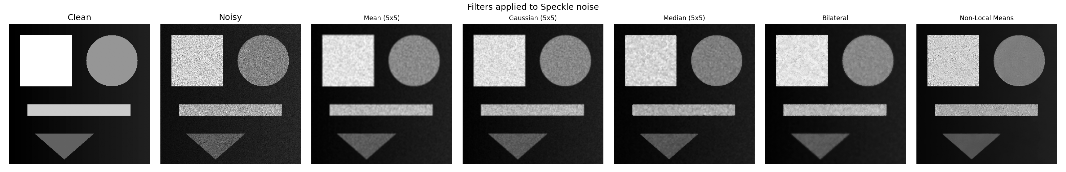
Figure 4. Comparison of all five filters applied to speckle-noise-corrupted image.
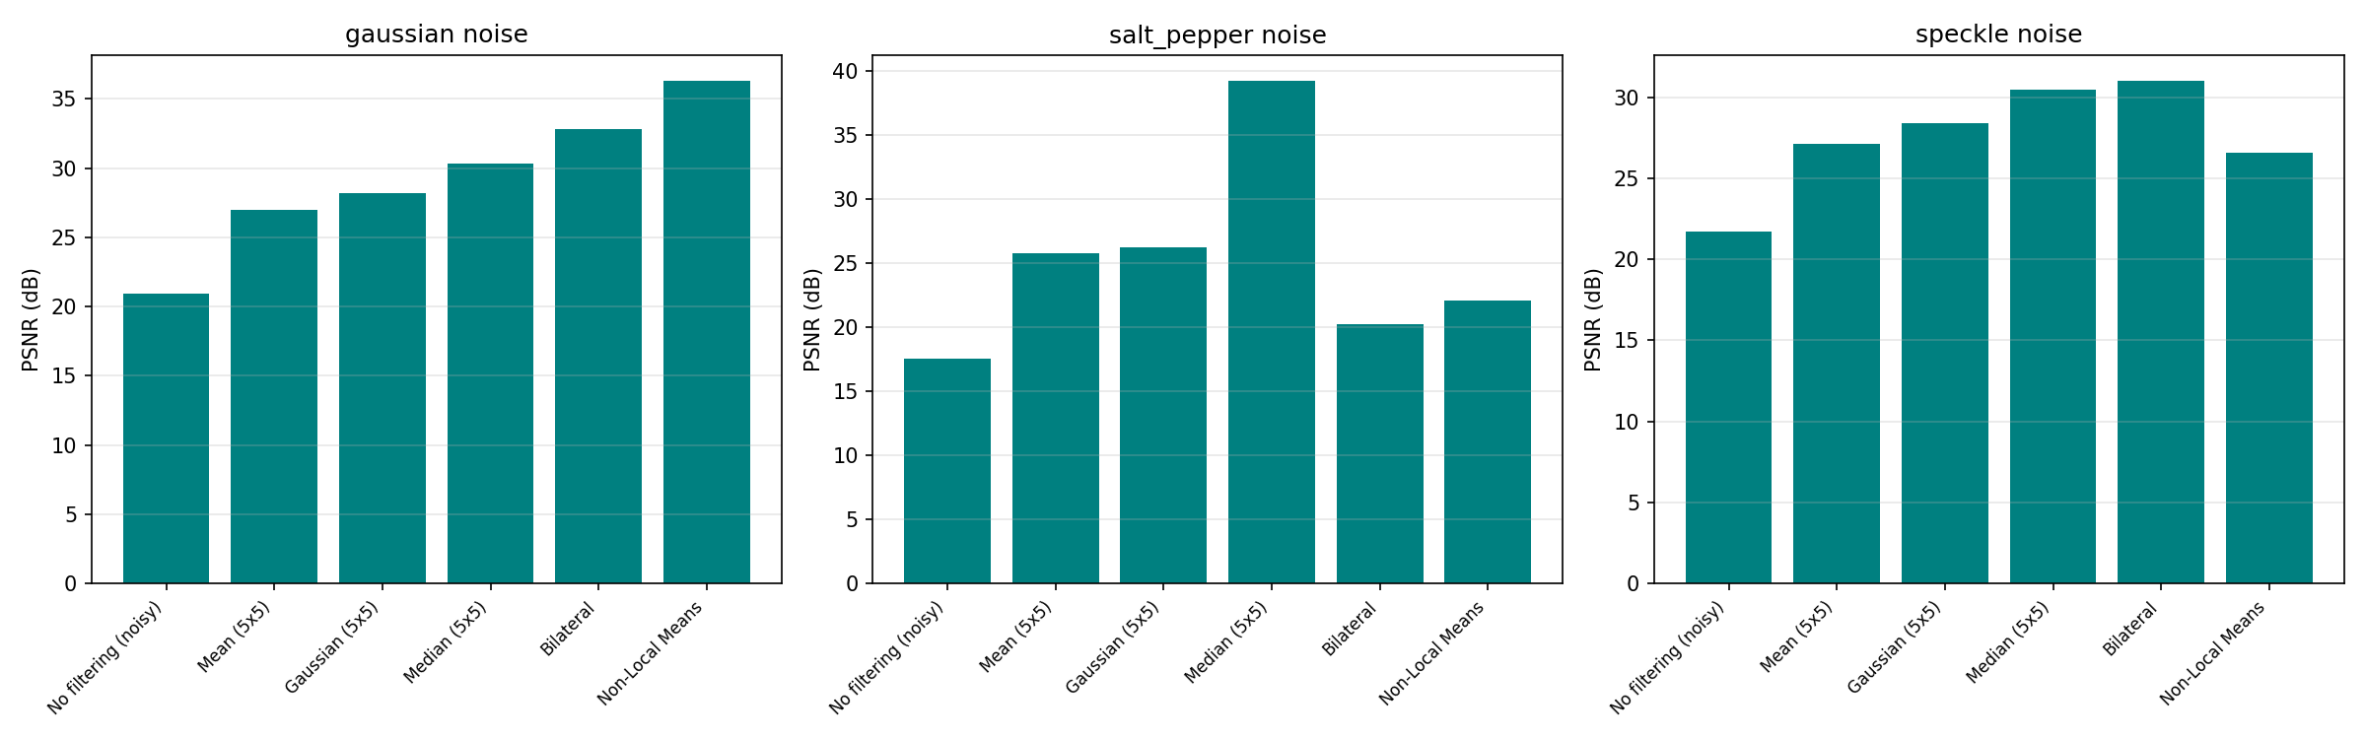
Figure 5. PSNR (dB) achieved by each filter, grouped by noise type.
Summary of measured metrics:
Noise Type | Filter | PSNR (dB) | SSIM
gaussian | No filtering (noisy) | 20.94 | 0.174
gaussian | Mean (5x5) | 27.0 | 0.774
gaussian | Gaussian (5x5) | 28.21 | 0.706
gaussian | Median (5x5) | 30.31 | 0.698
gaussian | Bilateral | 32.85 | 0.845
gaussian | Non-Local Means | 36.34 | 0.939
salt_pepper | No filtering (noisy) | 17.52 | 0.291
salt_pepper | Mean (5x5) | 25.77 | 0.664
salt_pepper | Gaussian (5x5) | 26.25 | 0.594
salt_pepper | Median (5x5) | 39.24 | 0.997
salt_pepper | Bilateral | 20.24 | 0.455
salt_pepper | Non-Local Means | 22.08 | 0.579
speckle | No filtering (noisy) | 21.69 | 0.472
speckle | Mean (5x5) | 27.1 | 0.834
speckle | Gaussian (5x5) | 28.41 | 0.806
speckle | Median (5x5) | 30.46 | 0.826
speckle | Bilateral | 31.04 | 0.833
speckle | Non-Local Means | 26.57 | 0.81

5. Analysis of Results
For Gaussian noise, Non-Local Means achieved the best fidelity by a clear margin (PSNR 36.3 dB, SSIM 0.94), followed by Bilateral filtering (32.9 dB, 0.85). Both outperform the purely linear Mean and Gaussian filters (27.0 and 28.2 dB respectively), confirming that edge-aware/patch-based methods preserve structure noticeably better than simple local averaging when the noise is additive and spatially uncorrelated.
For salt-and-pepper noise, the Median filter was overwhelmingly the best choice (PSNR 39.2 dB, SSIM 0.997), far ahead of every other technique. This matches theoretical expectations: because impulse noise creates extreme outlier values, an average-based filter (mean, Gaussian, or even bilateral, which still blends neighbouring intensities) is pulled toward the corrupted pixel, whereas the median statistic is provably robust to a minority of extreme outliers within a window. Bilateral filtering in particular performed worse than doing nothing at all on this noise type (20.2 dB vs. 17.5 dB baseline is only a mild improvement, and its SSIM of 0.46 is well below the median filter's 0.997), because its range-weighting term treats the extreme salt/pepper values as another 'edge' to preserve rather than as noise to reject.
For speckle noise, results were more evenly distributed across filters, with Bilateral (31.0 dB) and Median (30.5 dB) performing best and Non-Local Means performing worse than usual (26.6 dB) relative to its strong Gaussian-noise performance, because speckle is signal-dependent (multiplicative) rather than the additive, spatially-uniform noise NLM's patch-similarity search assumes.
Across all three noise types, the un-filtered noisy baseline always scored lowest, confirming that every filter tested provides a genuine improvement -- but the single best filter is noise-model dependent, which is the central finding of this comparison.

6. Conclusion
- There is no universally optimal denoising filter; the correct choice depends on the statistical nature of the noise present in the image.
- Median filtering is the clear filter of choice for impulse-type (salt-and-pepper) noise, while Non-Local Means and Bilateral filtering are preferable for additive Gaussian noise, because they better preserve edges and fine detail than simple linear smoothing.
- Linear filters (mean, Gaussian blur) are computationally cheapest but consistently sacrifice the most structural detail (lowest SSIM in almost every noise category), making them a poor choice whenever edge/texture preservation matters.
- In practice, identifying (or estimating) the dominant noise model in a given imaging pipeline before selecting a denoising filter is essential to obtaining good restoration quality.

7. Documentation
All source code, the noisy datasets, output figures, and the raw metrics table (metrics.csv, containing PSNR/SSIM for every filter x noise-type combination) used in this report are included alongside this PDF in the accompanying noise_removal_comparison.py script and the outputs/ folder, allowing full reproduction of every result shown above.

